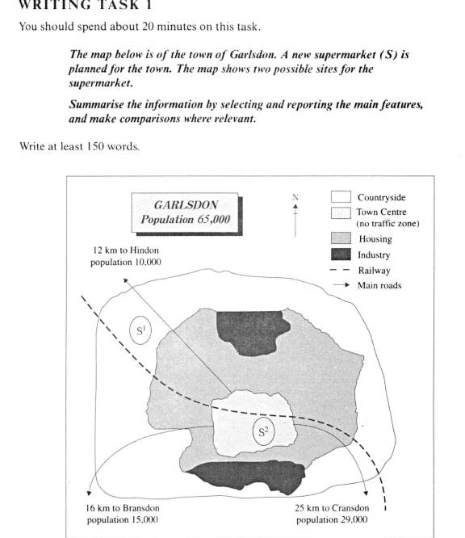

Introduction of The Sites of A New Supermarket in Garlsdon

*The first edition:*

Garlsdon is a big town which has the largest population in this area. The town has 65,000 residents which is more than those live in all of others three towns. These three towns, which are Hindon on the northwest, Bransdon on the southwest and Cransdon on the southeast, connect Garlsdon with three main roads and they are 12km, 16km and 25 km away for it, respectively.

The major part of the town is residential area, and the town centre, which is a no traffic zone, has a railway through it from southeast to northwest. Two industrial parks loate on north and south side of the town. There are large area of countryside around it.

The first optional site of the new supermarket is on the southwest side of town’s countryside and locates between the railway and the main road to Hindon. The second one is in the centre of the town beside the railway.

**The above essay is the first edition.**

What is wrong with the first edition of the essay?

The first edition is not written correctly because it is not response to the topic of the task which is the sites of a new super market. On the contrary, it focuses on the town and its surrounding towns.

*The second edition*

The map demonstrates us two optional locations for a new supermarket in a town named Garlsdon which has a population of 65,000. In this town, three main roads are constructed to connect its neighbour towns which are Hindon, Bransdon and Cransdon and a railway is built running through its centre. In addition, there are also two industrial zones located north and south of the town.

To begin with, the first one is located north-west part of the town and is between the railway and a main road to Hindon. It is situated in the outskirts of the residential area of the town.

Whereas, the seond choice is right in the centre of the centre of the town, which is also a traffice-free zone. Furthermore, a railway station is nearby and the another two towns are nearer to it than the first place.

To summarise, the second place is possible better than the first because it is near the railway station and the town itsself has the largest population among these four. Another reason is that residents in another two towns will find it is convenient to go shopping in the new supermarket.